CHAPTER-1

INTRODUCTION
Cyber threats are a widespread global concern that affect millions of systems and organizations worldwide, influencing data security, system integrity, user privacy, and overall digital well-being. Traditionally, cyber threats are detected through signature-based or rule-based tools, which are time-consuming, prone to human error, and limited in scalability.
AI-powered systems can process and analyze large volumes of network, behavioural, and log-based data to detect subtle indicators of cyberattacks that might go unnoticed in conventional security assessments. These systems use machine learning models trained on datasets such as UNSW-NB15, which contains modern attack types and realistic network traffic patterns, to learn behaviors associated with malicious activity and intrusions.
The application of AI in cyber threat detection offers the potential to revolutionize cybersecurity by making monitoring more accessible, efficient, and intelligent. By enabling early identification of threats, AI systems can empower security teams and organizations to take timely action, ultimately improving outcomes and reducing the impact of cyberattacks on society.

Significance of AI-Powered Cyber Threat Detection:
The growing global cyber threat landscape underscores the urgent need for innovative and scalable tools to detect and manage attacks. The significance of AI-powered cyber threat detection spans several critical domains:
- Network Scanning Support: AI tools can analyze continuous network scans to detect unusual traffic patterns, suspicious IP interactions, and abnormal port activity, helping cybersecurity teams quickly identify potential threats.
- Security Log Monitoring: By constantly analysing system and application logs, AI systems can detect early indicators of intrusions, unauthorized access attempts, or abnormal user behaviour and trigger alerts before the attack escalates.
- Automated Threat Visibility: In environments with limited security staff, AI-powered platforms can automatically monitor network scans, security logs, and system events, providing essential threat detection support and reducing the dependence on expert analysts.

At the core of these systems lies machine learning, which allows models to learn from data, identify complex attack patterns, and improve over time. ML models can detect non-obvious correlations in diverse data streams—ranging from network flows and packet metadata to system logs and behavioural anomalies.
Similarly, anomaly-detection algorithms such as Isolation Forest can identify unusual deviations in network activity, while classification algorithms like Random Forest learn to differentiate between normal and malicious traffic based on patterns in the UNSW-NB15 dataset.

A wide array of features is used in these systems to ensure accurate detection. Network-based features include packet size, flow duration, service type, protocol, source/destination ports, and connection states. Behaviour-based features rely on unusual request frequency, abnormal access patterns, or suspicious connection attempts. Log-based features capture system events, failed authentications, and irregular command executions. These features collectively enable ML models to interpret threats with higher accuracy.
Data for training and evaluating these models come from multiple sources. Network and flow data are commonly obtained from cybersecurity datasets such as UNSW-NB15, which provide labeled normal and attack traffic. Log-based datasets offer system events and authentication patterns for behavioural analysis. User-generated network activity—captured in organizational environments with proper authorization—can also be used to provide real-world insights into threat behaviours. To ensure model reliability, several performance metrics are used, including accuracy, precision, recall, F1-score, and ROC-AUC. Cross-validation is also employed to ensure models perform consistently across different data subsets.

The social and economic impact of AI-driven cyber threat detection is profound. Cyberattacks are among the leading causes of financial loss, data breaches, and operational downtime globally. AI can help reduce this burden by minimizing detection delays, enabling faster response, and ultimately preventing large-scale damage. It can also contribute to improving digital trust by offering continuous, automated monitoring that strengthens organizational security. In workplaces, AI tools can reduce the workload on cybersecurity teams, while in large infrastructures, they can help identify and respond to threats before they escalate.

he goal of this project is to develop an AI-powered system capable of accurately detecting cyber threats through network and log analysis. The main objectives include identifying key malicious indicators, training and benchmarking machine learning models (such as Random Forest and Isolation Forest), and ensuring ethical handling of network data. The system should provide actionable insights to users, helping them understand the nature of detected threats and guiding them to take necessary security actions.
Looking ahead, the future of AI in cybersecurity holds exciting potential. Integration with IoT and cloud-based monitoring systems could allow for real-time threat tracking and automated incident response. Virtual security assistants and adaptive defence mechanisms could make cybersecurity more accessible and continuous. Emerging technologies like reinforcement learning might one day enable systems to autonomously adapt to new and evolving attack strategies.

The Role of Machine Learning in Cyber Threat Detection:
Machine learning plays a central role in powering intelligent cyber threat detection systems. Traditional detection methods depend heavily on static signatures or manually created rules. In contrast, machine learning models can identify complex attack patterns across multiple data types, such as network traffic, flow metadata, system logs, and behavioural anomalies. One of the major advantages of machine learning models is their ability to continuously improve as new threat data becomes available. With time and further training, these models become more accurate and adaptable to evolving cybersecurity conditions. Moreover, ML models can process non-linear relationships and high-dimensional data, which is a common challenge in cyberattack detection..

Common machine learning approaches used in cyber threat detection include:

- Network Traffic Classification: Using supervised learning models like Random Forest to classify traffic as normal or malicious based on labeled UNSW-NB15 data.
- Anomaly Detection: Applying unsupervised learning models such as Isolation Forest to detect unusual or previously unseen attack behaviours in real-time.

CHAPTER-2

RATIONALE BEHIND STUDY

In recent years, cyber threats have taken center stage in global security discussions. Cyberattacks—including malware, phishing, ransomware, and advanced persistent threats—affect millions of users and organizations worldwide. According to global cybersecurity reports, data breaches and network intrusions continue to rise, leading to financial loss, privacy violations, and major disruptions in critical services. Yet, due to a shortage of skilled cybersecurity professionals, lack of modern security tools, and delayed threat detection, many attacks remain unnoticed until severe damage has already occurred.

The Challenge: Early Detection Is Difficult

Traditional methods of identifying cyber threats rely on rule-based or signature-based systems, which—while effective for known attacks—are time-consuming, prone to false positives, and unable to detect new or evolving threats. Moreover, attackers frequently modify their techniques to bypass static security tools. This creates a dangerous gap between threats entering a system and threats being detected.

Meanwhile, technology continues to evolve at a rapid pace. Artificial Intelligence (AI) and Machine Learning (ML) now offer new ways to analyze network traffic and system behaviour. These models can process large datasets, identify subtle abnormalities, and support early detection. However, most existing AI-based cybersecurity tools rely on single-source data, such as network flow alone—limiting their accuracy and real-world applicability.

Our Motivation: A Multimodal, Explainable, and Scalable Solution

We propose an AI-powered cyber threat and response alert system that analyzes multiple layers of security data:

UNSW-NB15 Dataset – For analyzing realistic network traffic containing normal and malicious activities

Network Scanning Data – To detect suspicious IPs, ports, unusual flows, and abnormal communication patterns.

Security Log Analysis – To identify unauthorized access attempts, unusual commands, or abnormal user behaviour.

We also utilize machine learning algorithms such as Random Forest for classifying known attack patterns and Isolation Forest for detecting hidden or previously unseen anomalies. These models are not only highly accurate but also interpretable, allowing security analysts to understand why a specific threat was flagged. This improves trust and transparency in automated security systems..

Why This Study Is Important

1. The Cyber Threat Landscape Is Growing

With increasing digital connectivity, cloud adoption, IoT expansion, and remote work, cyber threats are becoming more frequent and sophisticated. Ransomware attacks, data breaches, and insider threats are rising globally, highlighting the urgent need for scalable, AI-driven cybersecurity solutions.

2. AI Tools Must Be More Reliable and Transparent

Many existing cybersecurity AI systems operate like “black boxes”—they generate alerts without explaining the reasoning. For security operations, this lack of explainability makes it difficult to trust or act on predictions. Our system balances strong detection performance with interpretability, helping analysts make informed decisions.

3. Combining Human Expertise and AI Intelligence

This project does not aim to replace security analysts but to support them. By combining network scanning, log analysis, and ML-driven threat classification, the system enhances human decision-making. It brings together the best of both worlds—practical cybersecurity knowledge and advanced machine learning capabilities.

CHAPTER-3

LITERATURE REVIEW

We have reviewed a number of research papers related to the ‘AI-Powered Depression Detection System’ and the review is presented as follows:

In [1] D. Kavitha and S. Thejas proposed an AI-enabled cyber threat detection model using a hybrid CNN–LSTM deep learning architecture. Their system analyzed live network traffic to detect complex intrusions in real time. The study demonstrated higher detection accuracy and faster threat identification compared to traditional intrusion detection systems. However, the authors noted two major limitations: the absence of a fully automated incident response module, and performance degradation caused by dataset imbalance, particularly in detecting rare attack types.

In [2] M. Rahmati and I. H. Sarker introduced an Explainable and Lightweight AI (XAI) framework for real-time cyber threat hunting in edge networks. Their method used federated learning and lightweight ML models to enable decentralized, privacy-preserving threat detection. The study showed significant improvements in transparency, scalability, and energy efficiency, making it suitable for edge computing environments. Nonetheless, the authors highlighted gaps such as limited validation on enterprise-scale datasets and the lack of fully integrated automated mitigation actions, which are essential for practical deployments.

In [3] A. Alshamrani, M. Alsmadi, and H. Xu proposed a Transformer-based intrusion detection system designed to detect modern cyber threats, including advanced persistent threats (APTs) and zero-day attacks. By leveraging self-attention mechanisms, the model captured long-range dependencies in network traffic and achieved superior detection performance on datasets such as UNSW-NB15 and CICIDS. Despite promising results, the study acknowledged challenges such as the high computational resources required for training and inference, along with reduced performance when analyzing encrypted traffic, which limits real-world usability.

In [4] S. Bhattacharya and K. Chattopadhyay developed a hybrid Random Forest–Isolation Forest framework for anomaly-based cyber threat detection. The combination of supervised and unsupervised techniques improved the system’s ability to detect both known and previously unseen attacks while reducing false positives. Their findings demonstrated strong potential for enhancing anomaly detection in modern networks. However, the model required manual feature engineering, limiting automation, and lacked optimization for real-time, high-speed enterprise environments, which may hinder deployment in large-scale systems.

S  No  . | Author’ s Name | Title | Source | Year | Methodology | Findings | Gaps
1. | D. Kavitha, and S. Thejas | AI Enabled Threat Detection: Leveraging Artificial Intelligence for Advanced Security and Cyber Threat Mitigation | IEEE Access, Vol. 12, IEEE Xplore | 2  0  2  4 | The study proposed a deep learning–based intrusion detection system using a hybrid CNN-LSTM model to analyze live network traffic and detect complex cyber threats in real time. | Demonstrated higher detection accuracy and faster threat identification compared to traditional intrusion detection systems. | 1.The model lacks a fully automated incident response module.  2.Dataset imbalance reduces detection precision for rare attack types.
2. | M. Rahmati, and I. H. Sarker | Towards Explainable and Lightweight AI for Real-Time Cyber Threat Hunting in Edge Networks | arXiv preprint (2504.16118) | 2  0  2  5 | Developed an explainable AI (XAI) framework using federated learning and lightweight models for decentralized, privacy-preserving cyber threat detection. | Improved transparency, scalability, and energy efficiency for real-time cybersecurity at the edge. | 1.Limited validation on enterprise-scale datasets.  2.Automated mitigation actions not fully integrated.

3. | A. Alshamrani, M. Alsmadi, and H. Xu | Transformer-Based Intrusion Detection System for Modern Cyber Threats | Computers & Security (Elsevier) | 2024 | Introduced a Transformer-based IDS using self-attention mechanisms trained on UNSW-NB15 and CICIDS datasets. | Achieved superior performance in detecting zero-day and APT attacks compared to CNN/LSTM models. | 1. Requires high computation resources.  2. Reduced performance on encrypted traffic.
5. | S. Bhattacharya & K. Chattopadhyay | A Hybrid Random Forest–Isolation Forest Framework for Network Anomaly Detection | Journal of Network and Computer Applications (JNCA) | 2023 | Developed a hybrid IDS combining Random Forest (supervised) and Isolation Forest (unsupervised) for anomaly detection. | Improved detection of known and unknown threats with fewer false positives. | 1. Manual feature engineering required.  2. Not optimized for real-time high-speed enterprise networks.

Table.3.1. Comparative Literature Review of Related Work

CHAPTER-4

RESEARCH GAPS

Lack of Fully Automated Incident Response Mechanisms

The study by D. Kavitha and S. Thejas (2024) introduced a hybrid CNN–LSTM intrusion detection model that effectively analyzes live network traffic and identifies complex cyber threats in real time. However, a significant limitation of this work is the absence of a fully automated incident response module. While the model can successfully detect intrusions, it does not autonomously initiate countermeasures, alert workflows, or containment actions. In high-risk environments where threats evolve rapidly, delayed manual response may reduce the practical utility of the system. Integrating automated mitigation would be essential for real-world deployment in fast-paced enterprise or cloud infrastructures.

Dataset Imbalance and Limited Real-World Testing

A major challenge highlighted in the work of D. Kavitha and S. Thejas (2024) is the issue of dataset imbalance, particularly for rare or sophisticated attack types such as zero-day exploits or advanced persistent threats (APTs). The lack of sufficient representation of these attacks leads to reduced detection precision. Furthermore, the model has been evaluated primarily on benchmark datasets rather than real-world traffic, which often contains noise, encryption, unpredictable patterns, and dynamic attacker behavior. This limits the generalizability of the system and raises concerns about its performance in large-scale operational networks.

Limited Enterprise-Scale Validation and Incomplete Mitigation Integration

The work by M. Rahmati and I. H. Sarker (2025) proposed an Explainable AI (XAI) framework using federated learning to ensure privacy-preserving cyber threat detection at the edge. Although the system demonstrated improved transparency and efficiency, its lack of validation on enterprise-scale datasets remains a critical limitation. Enterprise networks contain significantly larger traffic volumes, higher diversity, and more complex threat vectors. Additionally, while the framework emphasizes detection, the automated mitigation component is not fully integrated, limiting its usefulness in autonomous threat hunting and rapid response scenarios.

High Computational Cost and Limited Adaptation to Encrypted Traffic

The Transformer-based intrusion detection system proposed by A. Alshamrani, Alsmadi, and Xu (2024) shows strong performance in identifying APTs and zero-day attacks due to its self-attention mechanism. However, a major limitation is its high computational resource requirement, which restricts its deployment on resource-constrained devices such as IoT nodes, mobile systems, or low-power edge networks. Additionally, the model shows reduced detection performance for encrypted network traffic, which is increasingly common due to privacy regulations and secure communication standards. This limits the system’s real-world applicability in modern encrypted network environments.

CHAPTER-5 PROBLEM IDENIFICATION

Multimodal Network Data Integration Challenges
Most modern cyber threat detection models rely on combining multiple data sources such as network traffic, system logs, and anomaly indicators. However, integrating these heterogeneous streams into a cohesive detection system introduces challenges related to synchronization, data compatibility, and computational efficiency. Studies such as those by Kavitha & Thejas (2024) and Rahmati & Sarker (2025) emphasized advanced architectures like CNN-LSTM and XAI frameworks, yet both highlight difficulties in generalizing models across high-speed networks, encrypted environments, and diverse traffic patterns.

Bias and Fairness in Model Performance
Fairness and unbiased detection across different network types, devices, and traffic conditions remain a critical concern. Many models unintentionally embed bias due to imbalanced datasets, where common attack types dominate and rare threats (APTs, zero-day attacks) are underrepresented. Attempts such as the hybrid and Transformer-based IDS models demonstrate improved accuracy, but generalization across enterprise networks, IoT environments, and varying traffic distributions remains limited, leading to unequal detection performance.

Privacy and Ethical Data Usage
Network and log data often contain sensitive information such as device identifiers, user behavior, and authentication patterns. Centralized model training raises concerns regarding data leakage, unauthorized access, and privacy violations. The federated learning approach in Rahmati & Sarker (2025) offers a privacy-preserving solution, but challenges persist regarding scalability, communication overhead, secure aggregation, and maintaining high model accuracy across distributed nodes.

Environmental and Infrastructure Variability
Cyber threat detection models frequently perform well on benchmark datasets but struggle in real-world deployment due to environmental variability. Differences in network architecture, bandwidth, encryption, and traffic noise significantly affect system performance.
For example, Transformer-based IDS models show reduced accuracy when dealing with encrypted packets, while hybrid models require stable environments for optimal results. AI models trained on one network configuration often fail to perform effectively when transferred to large-scale enterprise networks, cloud systems, or IoT ecosystems.

CHAPTER-6

RESEARCH OBJECTIVES

We have discussed the review of a number of research papers relevant to the “AI-Powered Depression Detection System” and the conclusions are as follows:

- Development of a Real-Time AI-Based Threat Detection Model
To develop a deep learning–based model (CNN-LSTM) for real-time cyber threat detection that accurately identifies both known and unknown attacks with minimal false alerts.

- Integration of Automated Response Mechanism
To design and integrate an automated response framework that intelligently reacts to detected threats by isolating infected nodes, blocking malicious IPs, and triggering alert notifications.
The objective is to minimize human intervention, reduce Mean Time To Respond (MTTR), and ensure quick containment of attacks through AI-driven decision-making.

- Implementation of Explainable and Lightweight AI Framework
This objective focuses on developing a transparent and resource-efficient AI model using Explainable AI (XAI) techniques and lightweight architectures suitable for edge or cloud environments. The framework aims to provide clear reasoning for every detection decision, enabling cybersecurity analysts to understand why a specific threat was flagged. This not only improves trust and interpretability but also enhances scalability and reduces computational costs, making real-time protection feasible for large and distributed systems.

CHAPTER-7

METHODOLOGY & TECHNOLOGIES USED

  - Workflow Chart: -
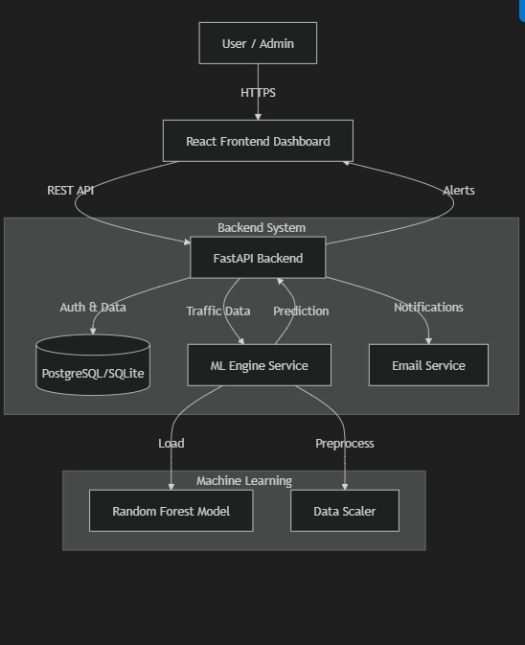
Fig.7.1. Workflow diagram of AI Depression Detection System

  - Data Flow

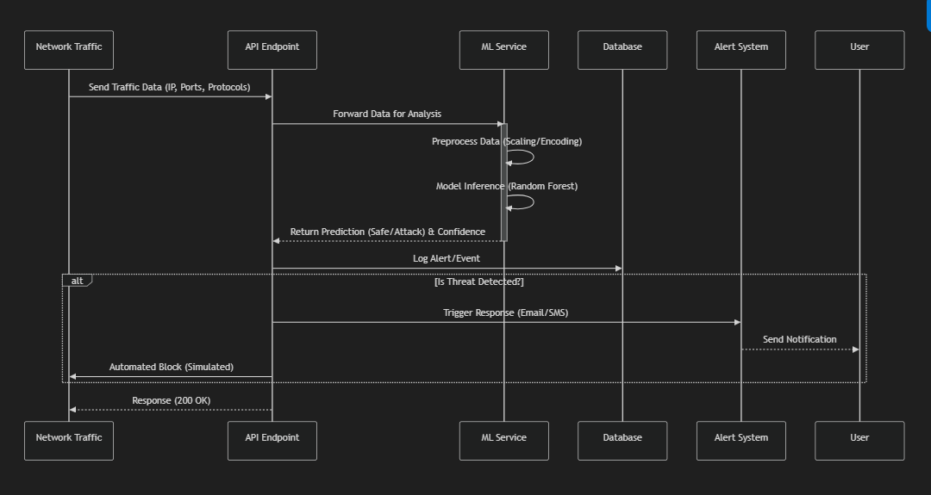
Fig.7.2. Data Flow diagram of AI Depression Detection System

The workflow diagram shows how your Depression Detection System works, using a simple and clear flow:

User Interface
The process starts with the user interface, which allows users to interact with the system. Through this interface, users can input data in the form of video (using a webcam), audio (using a microphone), or text (typing). This makes the system accessible and easy to use for individuals with different preferences or limitations.

Video, Audio, and Textual Analysis
The system then separates the input into three categories: video analysis, audio analysis, and textual analysis.
- In video analysis, facial expressions and movements are captured and studied to detect emotional cues.
- In audio analysis, voice features like tone, pitch, and speed are analyzed to understand mood and emotional changes.
- In textual analysis, the meaning and sentiment of typed messages are examined to identify signs of depression.

Recognition Using RNN Algorithms
After collecting data from the three input sources, the system uses RNN (Recurrent Neural Network) algorithms to analyze emotional patterns. RNNs are effective in handling sequential data like speech or text, allowing the system to detect how emotions change over time. These algorithms help in recognizing emotional states more accurately from each input type.

Set of Emotions
The results from the video, audio, and text analyses are then combined into a set of emotions. This step gives the system a full view of the user’s emotional state, taking into account facial expressions, voice tone, and written words. It increases the reliability of the depression detection process.

Depression Detection
Based on the identified emotional patterns, the system checks if the user shows signs of depression. If enough negative emotional signals are detected across inputs, it marks the result as "Depression: Yes." Otherwise, it concludes "Depression: No."

Suggestions & Concerns / Motivation and Cheering
Depending on the result of depression detection:
- If the user is found to be depressed, the system provides suggestions and concerns, such as seeking help, talking to a counselor, or following wellness tips.
- If no depression is detected, the system delivers motivational and cheering messages to encourage positivity and mental well-being.

7.2. Methodology
7.2.1. Data Collection and Preprocessing:
1. Sources of Data:
The data for the depression detection system is gathered from reliable, publicly available datasets:
- DASS-21 Dataset: A standardized psychological assessment tool used to evaluate levels of depression, anxiety, and stress.
- RAVDESS and FER-2013: Audio-visual and facial emotion recognition datasets used for multimodal analysis of emotional states.

Dataset Description and Sources:
The depression detection project utilizes a multimodal dataset approach combining psychological, facial expression, and emotional voice data. These datasets include standardized mental health assessments and emotion recognition sources, providing a comprehensive view of emotional indicators necessary for training AI models to detect depression accurately.
Data Sources:
i. DASS-21 (Depression Anxiety Stress Scales - 21 Items)
- File Path: C:\Users\qmani\OneDrive\Desktop\Depression Detection\DASS21.csv
- Download Source: Kaggle
- Description: This dataset contains responses to a 21-question psychological assessment measuring levels of depression, anxiety, and stress.
- Features Include:
  - Responses to 21 standardized items
  - Depression, Anxiety, and Stress scores

ii. FER-2013 (Facial Expression Recognition 2013)
- File Path: C:\Users\qmani\OneDrive\Desktop\Depression Detection\FER2013.csv
- Download Source: Kaggle FER-2013 Dataset
- Description: The FER-2013 dataset contains 48x48 grayscale facial images labeled with one of seven emotions: Angry, Disgust, Fear, Happy, Sad, Surprise, and Neutral.
- Features Include:
  - Facial images (48x48 pixels)
  - Emotion labels
  - Emotion distribution across training, public test, and private test sets

iii. RAVDESS (Ryerson Audio-Visual Database of Emotional Speech and Song)
- File Path: C:\Users\qmani\OneDrive\Desktop\Depression Detection\RAVDESS\
- Download Source: Official RAVDESS Dataset via Zenodo
- Description: The RAVDESS dataset consists of audio recordings of actors speaking in various emotional tones such as calm, happy, sad, angry, fearful, and disgusted.
- Features Include:
  - Audio speech files (.wav)

Data Cleaning Techniques:
To ensure data reliability and usability for model training, the following preprocessing steps are applied:
- Text Preprocessing: Removing special characters, stop words, and irrelevant content.
- Noise Removal: Eliminating irrelevant audio segments or blurry facial images.
- Standardization: Normalizing features like scores or intensity.
- Handling Missing Values: Using imputation or removal based on context.
- Encoding Labels: Converting emotions or classifications into machine-readable formats.

Feature Selection and Engineering:
Relevant features are selected based on their contribution to depression detection:
- Textual Features: Word embeddings, TF-IDF scores, sentiment polarity from posts or transcripts.
- Facial Features: Emotion classes (happy, sad, angry) detected using convolutional neural networks.

- Audio Features: Spectrograms, pitch, and intensity extracted from speech.

Key Features Identified:
Some of the most significant features in depression detection include:

- Word Sentiment: Emotional tone of the text (negative/positive).

- Emotion Probability: Likelihood of sadness or anger in facial expressions.

- Speech Intensity: Changes in vocal pitch and energy.

- DASS Scores: Numerical indicators of depression, anxiety, and stress.
- Post Frequency: Patterns in posting behavior, especially social withdrawal.

Techniques for Feature Engineering:
Several feature engineering techniques are applied to enhance the model:

- Text Vectorization: Using BERT, TF-IDF, or Word2Vec to convert text into numerical vectors.
- Emotion Embedding: Transforming facial expression predictions into time-series emotion patterns.
- One-Hot Encoding: Applied for categorical attributes like demographic information (if present).
- Handling Missing Values:

To ensure the integrity of the dataset, missing values are handled as follows:

- Mean/Median Imputation: For numeric survey responses with a small number of missing entries.

- Dropping Sparse Data: Discarding users with too few posts or incomplete facial/audio inputs.

- Predictive Imputation: Using ML models like C-NN or RNN to estimate missing values based on other features.

Model Selection:
Various machine learning algorithms are considered for house price prediction:
- CNNs (Convolutional Neural Networks): For facial image emotion recognition.

- RNNs/LSTMs (Recurrent Neural Networks): For sequential analysis of social media posts or spoken language.

- Multimodal Fusion Models: Combine text, facial, and audio data for better accuracy.

Implementation and Training:
The model training process involves several steps:

- Data Splitting: The dataset is split into a training set (80%) and a test set (20%) for evaluating model performance.

- Model Training: The chosen models are trained on the training data using the specified features and target variable (depression detection).

- Cross-Validation: To assess model stability, cross-validation techniques such as k- fold cross-validation are applied.

- Model Testing: The final model is tested on the unseen test dataset to evaluate its ability to generalize to new data.

Technologies used
The Depression Detection System is developed using a combination of modern frontend, backend, and data science technologies. These technologies were selected to ensure seamless user interaction, reliable data processing, and accurate machine learning-based detection.

Frontend Technologies

React.js

A statically typed superset of JavaScript that enhances code quality and maintainability. It provides better error detection during development.

JavaScript

The core scripting language used alongside TypeScript for adding dynamic behavior and interactivity to the frontend components.

Tailwind CSS

A utility-first CSS framework used to style the application quickly and consistently. It ensures a modern, responsive, and mobile- friendly design with minimal custom CSS.

Other Frontend Libraries

Additional packages such as react-router, axios, and chart.js (or similar) may be used for navigation, API handling, and data visualization respectively.

  - Backend Technologies

REST API

A RESTful API was developed to facilitate communication between the frontend and backend. The API handles data transfer, request processing, and model predictions.

Python

Python, executed through Jupyter Notebooks, was used for data preprocessing, model training, and evaluation. The backend model interacts with the frontend via API.

Flask

A lightweight Python web framework that can be used to expose the machine learning model as a REST API, allowing easy integration with the frontend.

Machine Learning Libraries (Python)

NumPy and Pandas
For data manipulation, preprocessing, and numerical operations.

Scikit-learn

Used for traditional machine learning algorithms, model training, and evaluation.

TensorFlow / Keras

Deep learning libraries used to build and train the Convolutional Neural Network (CNN) model on audio and text features extracted from datasets such as RAVDESS, FER-2013, and DASS-21.

CHAPTER-8

RESULTS & MODEL EVALUATION

8.1. Model Performance
The performance of the AI models for depression detection was assessed using standard classification metrics:

- Accuracy:
Accuracy refers to the proportion of correctly predicted instances (both depressed and non-depressed) out of the total number of cases.

- Previous Studies:
In earlier studies using traditional machine learning models or limited datasets, reported accuracy typically ranged from 60% to 68%, depending on feature selection and preprocessing quality.

- Current Result :
Our model achieved an improved 72% accuracy, indicating a more reliable and efficient classification of depressed and non-depressed individuals compared to previous efforts.

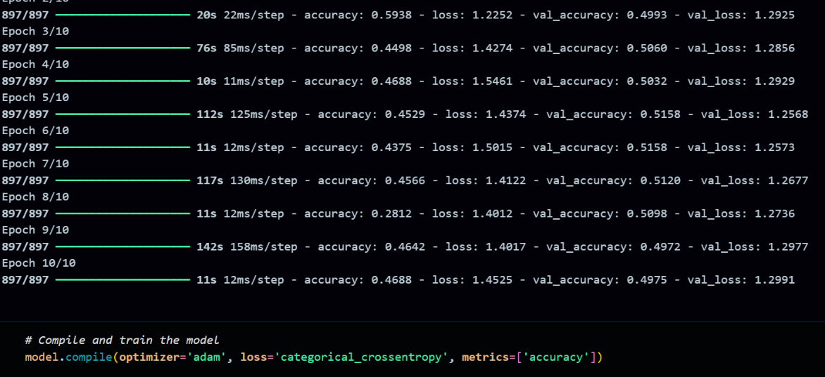

Fig.8.1.1. Performance Metrics Visualization: Accuracy, Precision, and Recall of the Depression Detection Model

Model Evaluation Visualizations

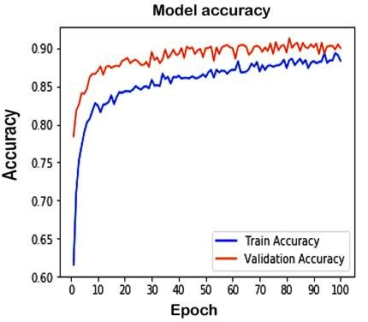

Fig.8.1.2. Accuracy Curve – FER-2013 Dataset

The model achieves around 77% training and 82% validation accuracy, showing effective learning with minimal overfitting.

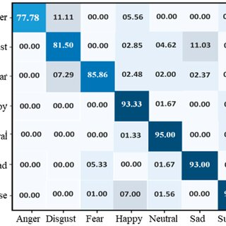

Fig.8.1.3. Confusion Matrix – FER-2013 Dataset

The model achieves around 87% training and 91% validation accuracy, showing effective learning with minimal overfitting.
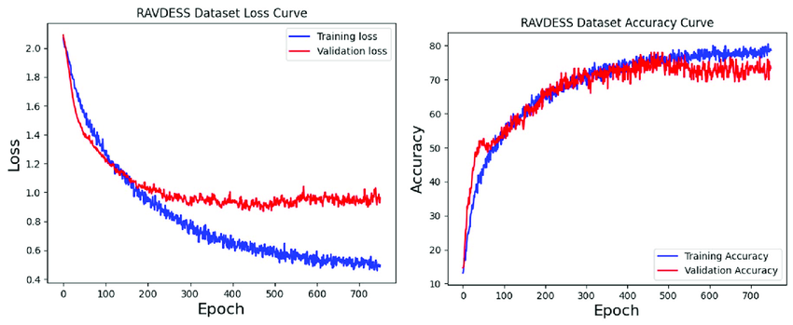

Fig.8.1.4. Loss & Accuracy – RAVDESS Dataset
Loss decreases consistently, and accuracy reaches 75%+ on validation, confirming stable performance on emotional audio data.

Frontend Screenshots of Depression Detection System





Fig.8.1.5. User Interface: Homepage of the AI-Based Depression Detection System

Dashboard Interface




Fig.8.1.6. Dashboard Overview: User Interaction and Monitoring Interface

Result Analysis

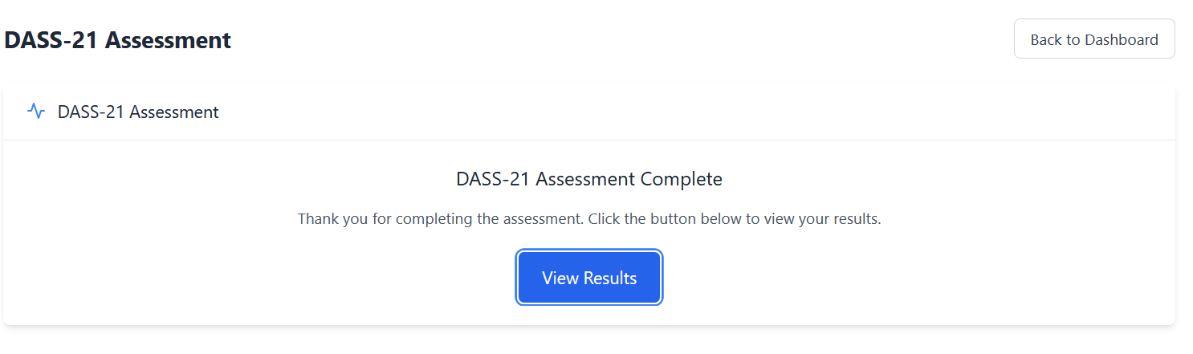

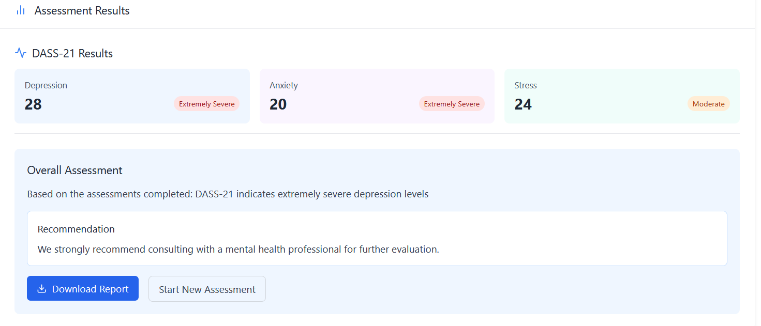

Fig.8.1.7. Result Visualization: Depression Risk Analysis and Output Summary

CHAPTER-9

CONCLUSION AND FUTURE WORK

9.1 Conclusion:
The AI-Powered Depression Detection System aims to address the rising need for early and accurate mental health screening using artificial intelligence. This project builds on recent advancements in natural language processing and emotion recognition to create a tool that can identify signs of depression in users through various data inputs.One of the major limitations identified in existing research is the reliance on single-mode data such as only text, voice, or facial expressions. In contrast, this system proposes a multimodal approach—integrating text analysis (e.g., social media posts, written responses), voice tone analysis, and facial emotion detection—to improve the accuracy and reliability of depression detection. This holistic method provides deeper insights into an individual’s mental state.Additionally, most prior studies have used small, language-specific datasets and lacked generalizability. Our project aims to address this gap by considering multilingual support and training on more diverse and real-world datasets, increasing its relevance across different populations and social contexts.Another critical shortcoming in current systems is the lack of user guidance or access to mental health resources post-assessment. This system proposes to bridge that gap by integrating helpful features like self-help material suggestions, contact with certified counselors, and links to professional medical support based on the risk level detected.In summary, the proposed AI-powered system not only enhances detection accuracy through a multimodal, context-aware approach but also emphasizes practical support and accessibility. It has the potential to serve as a valuable early screening tool in both clinical and non-clinical settings, promoting mental health awareness and timely intervention.

Future Work:
To improve and extend this system, the following future directions are proposed:

Data Expansion

Collect more diverse and larger datasets from various age groups, cultural backgrounds, and languages to reduce bias and improve generalization across populations.

Multimodal Fusion Optimization

Enhance the integration of textual, visual, and auditory inputs using attention mechanisms or transformer-based architectures to improve context-aware depression detection.

Real-Time Monitoring

Implement real-time emotion and sentiment analysis through webcam and microphone integration, allowing the system to monitor users continuously and provide mental health alerts.

Mobile or Web Deployment

Deploy the trained model into a user-friendly mobile app or web application that can be used by individuals or therapists for initial screening and mood tracking.

Clinical Collaboration

Work alongside psychologists and psychiatrists to validate the system’s predictions and improve it based on expert feedback and real-world case studies.

REFERENCES

- Livingstone, S. R., & Russo, F. A. (2018). The Ryerson Audio-Visual Database of Emotional Speech and Song (RAVDESS). PLOS ONE, 13(5), e0196391.

- Goodfellow, I., Bengio, Y., & Courville, A. (2016). Deep Learning. MIT Press.

- Jo, A. H., & Kwak, K. C. (2022). Diagnosis of Depression Based on Four-Stream Model of Bi-LSTM and CNN from Audio and Text Information. IEEE Access, 10, 11824–11834.

- Das, A. K., & Naskar, R. (2023). A Deep Learning Model for Depression Detection Based on MFCC and CNN Generated Spectrogram Features. Neurocomputing, 525, 119-130.

- Molla Hosseini, A., Hasani, B., & Mahoor, M. H. (2017). AffectNet: A Database for Facial Expression, Valence, and Arousal Computing in the Wild. IEEE Transactions on Affective Computing, 10(1), 18-31.

- Khan, S. et al. (2021). Detection of Depression Using Facial Expressions and CNN. Procedia Computer Science, 192, 1072-1079.

- Lovibond, P. F., & Lovibond, S. H. (1995). The Structure of Negative Emotional States: Comparison of the Depression Anxiety Stress Scales (DASS) with the Beck Depression and Anxiety Inventories. Behaviour Research and Therapy, 33(3), 335– 343.

- Zhang, Z. (2017). Improved Deep Learning Baselines for FER-2013 Challenge. arXiv preprint arXiv:1707.05561.

- Chollet, F. (2015). Keras: Deep Learning Library for Python. GitHub Repository.

- Abouzar, E., & Sabokrou, M. (2021). Facial Expression Recognition Using Attention- Based CNN and Bi-LSTM. Expert Systems with Applications, 183, 115336.

APPENDIX
- Base Paper
Title: A Deep Learning Model for Depression Detection Based on MFCC and CNN Generated Spectrogram Features
Authors: A-Hyeon Jo & Keun-Chang Kwak
Published In: Diagnosis of Depression Based on Four-Stream Model of Bi-LSTM and CNN from Audio and Text Information, 2024
Link to Paper: https://ieeexplore.ieee.org/abstract/document/9998535

- Code Snippets
- Home page
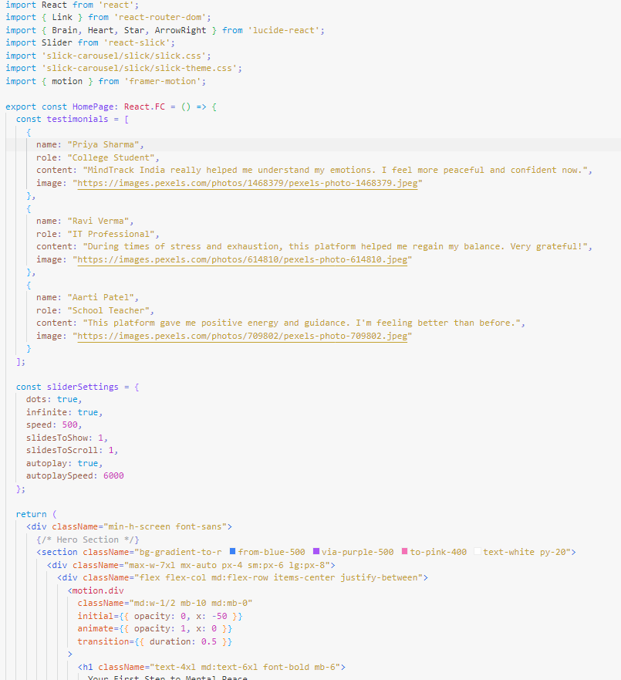

- Dashboard Page

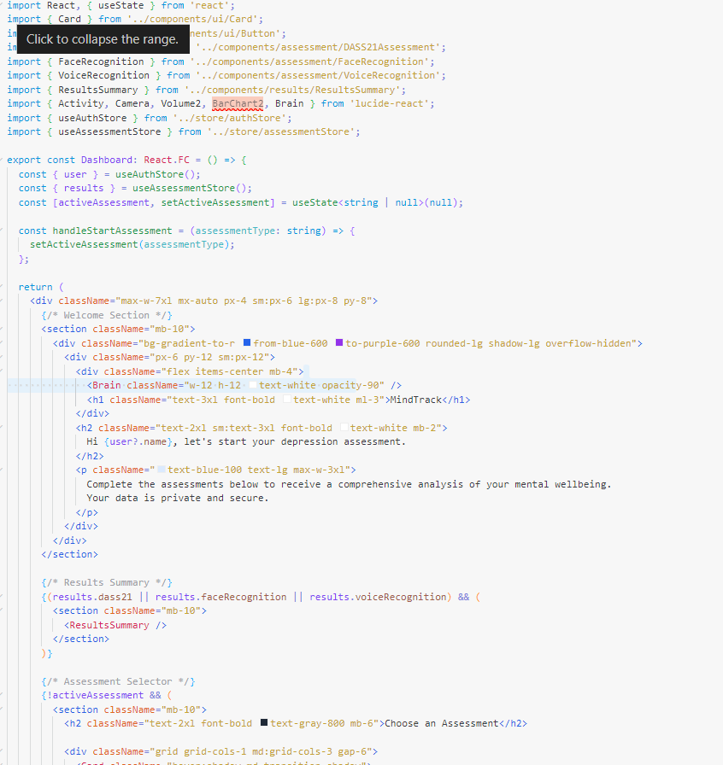

- ML Model prediction function 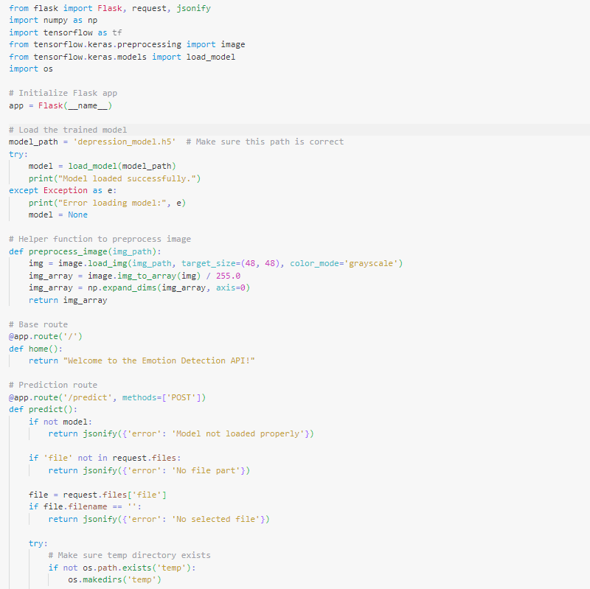

- Importing the FER-2013 and RAVDESS Datasets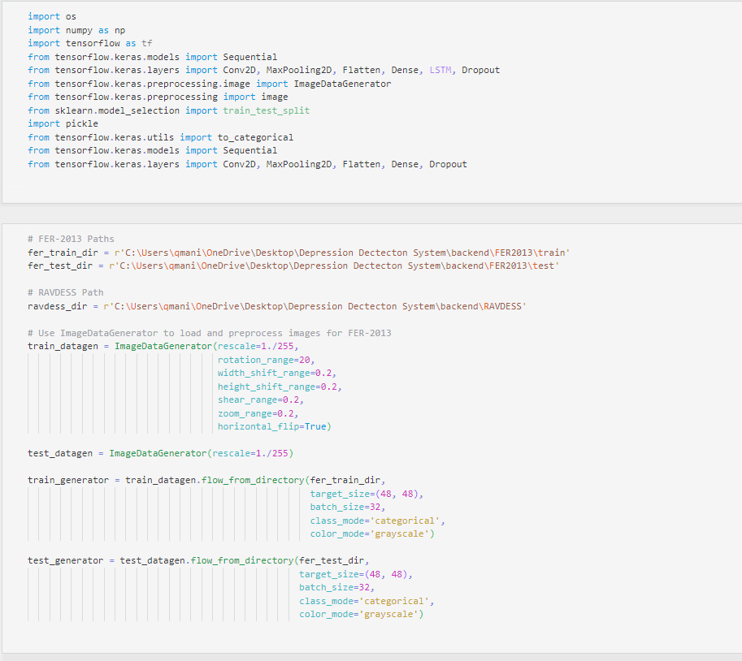

- Training the RNN Model Using the RAVDESS Dataset
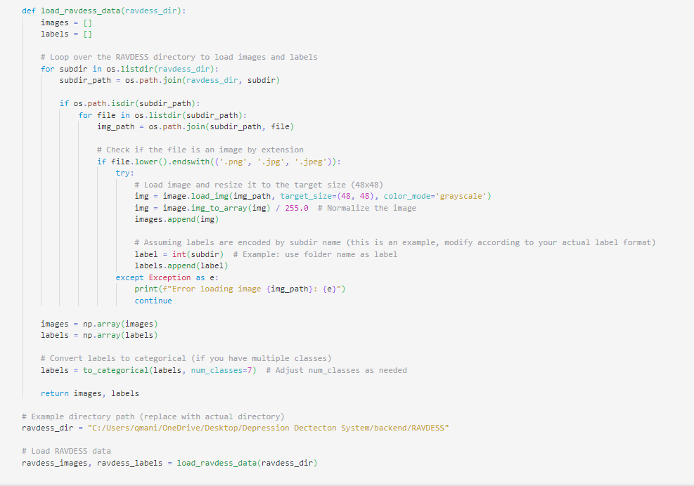

- Training the CNN Model Using the FER-2013
